MY400/500 – W3 – The Relationship between Theory and Data

Essential Readings

Fiorito T. Rm and Nicholls, W. J. 2016 “Silencing to Give Voice: Backstage Preparations in the Undocumented Youth Movement in Los Angeles” Qualitative Sociology 39: 287-308.

Legate, N., Ngyuen, T. V., Weinstein, N., Moller, A., Legault, L., Vally, Z., ... & Ogbonnaya, C. E. (2022). A global experiment on motivating social distancing during the COVID-19 pandemic. Proceedings of the National Academy of Sciences, 119(22).

Seminar activity

- Q&A about the lecture and refresher about what the lecture was about
- Discussion #1: Identifying research puzzles and research questions
- Discussion #2: Fiorito & Nicholls (2016) and Legate et al. (2022)

Lecture take-aways

Theory is a ‘way of thinking’ and a ‘way of seeing’ that allows you to produce a rich and impactful analysis. Theory allows you to ‘see something differently’, to define and explain a social/political phenomenon, by setting out key concepts and thinking through how explain the relationships between different concepts. By drawing on (and potentially developing) existing theoretical frameworks, we connect with our own discipline(s)/sub-discipline(s) and engage with an ongoing cumulative conversation in the literature.

Data are (formally, data is a plural noun, although there is a recent tendency to treat data as a singular noun) empirical observations that are organised by your research design and theoretical framework(s). How is theory and data related? A classic distinction is between deductive reasoning (start with a theory and test whether it applies in a specific context), inductive reasoning (start with empirical insights and think about how one could draw general statements) and abductive reasoning (look at/for deviant cases that throw an interesting light on existing knowledge/theory)

- There are several ways to combine theory and empirics. While hypothetico-deductive approaches may seem the most obvious depending on your disciplinary background, inductive approaches are at the heart of many social sciences.
- Theory can provide a "way of seeing" that can add clarity and insight to empirical observations. Concepts are also important.
- As you read... note what theory is being engaged with, and what assumptions are inherent within it.
- As you write... aim for theory-question-method alignment, and see which theory gives you the greatest intellectual purchase.
- Does anyone have any questions from the lecture; anything they didn’t understand; or any reflections they’d like to share?

Discussion #1: From research puzzles to research questions

The objective of this exercise is to practice thinking in terms of research puzzles and practicing formulating research questions. Refresh your memory about how to formulate research questions by revising the W1 lecture slides and having a look at the blog post: https://www.audreyalejandro.com/blog---the-methodological-artist/how-to-construct-and-formulate-research-questions

Have you started to think about your research topic and research question(s)? If so, can you think of a way of framing it as a research puzzle? Recall from the lecture:

- A research puzzle refers to an intriguing or puzzling observation, phenomenon, or gap in existing knowledge that sparks curiosity. It’s the broader context that motivates the research. A research puzzle often arises when something unexpected or contradictory is noticed, prompting the researcher to explore why things are the way they are. It tends to be open-ended and reflects a problem that lacks a clear explanation.
- A research question is more specific and focused, providing a direct inquiry that the research aims to answer. It stems from the research puzzle but is framed in a way that guides the research process. A well-defined research question is clear, precise, and answerable, laying the foundation for data collection and analysis.

If you can frame your early thoughts for your research proposal in terms of a research puzzle, come along to the seminar and be ready to tell your colleagues.

Read the four abstracts below, they will be the basis of the seminar exercise:

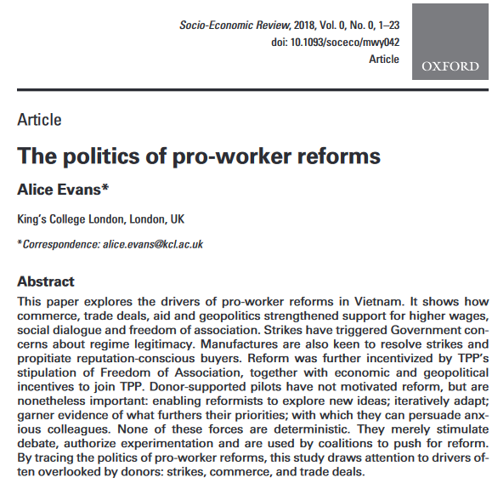
Evans, E. (2018). The politics of pro-worker reforms. Socio-Economic Review, 1-23.

The abstract you've shared seems to fit a developmental puzzle. It primarily addresses the how and why behind the development of pro-worker reforms in Vietnam. The focus is on understanding the specific drivers—such as commerce, trade deals, and geopolitical factors—that have contributed to the evolution of these reforms. Additionally, it explores the dynamics and influences that have motivated changes over time, particularly through the lens of political and economic factors, strikes, and external pressures like trade agreements.


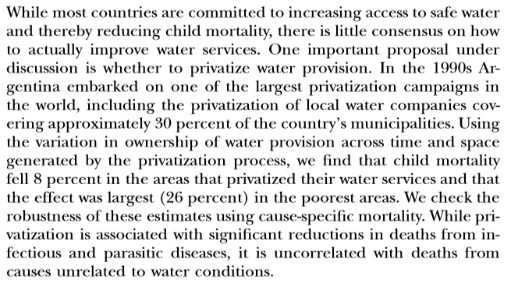
Galiani, S., Gertler, P., & Schargrodsky, E. (2005). Water for life: the impact of the privatization of water services on child mortality. Journal of Political Economy, 113(1), 83–120

This abstract presents a causal/predictive puzzle. It examines the effects of a specific intervention—privatization of water services in Argentina—on child mortality. The study looks into causal relationships by measuring changes in mortality rates, particularly in areas where privatization occurred, and predicts outcomes tied to water-related diseases. The emphasis on determining the cause-and-effect relationship between privatization and health outcomes, as well as testing these associations for robustness, aligns with the causal/predictive puzzle type.

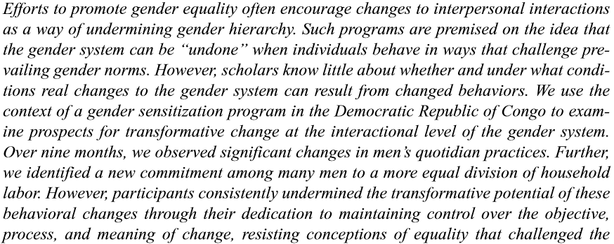
Pierotti, R. S., Lake, M., & Lewis, C. (2018). Equality on His Terms: Doing and Undoing Gender through Men’s Discussion Groups. Gender & Society, 32(4), 540–562. https://doi.org/10.1177/0891243218779779

This abstract fits a mechanical puzzle. It investigates how a gender sensitization program works at an interactional level and whether changes in behavior among men can meaningfully transform the broader gender system. The focus is on understanding the mechanisms by which interpersonal interactions and behavior changes affect (or fail to affect) the entrenched gender hierarchy. By exploring the processes and dynamics that allow or inhibit these changes, this study seeks to uncover the underlying workings of the gender system and why certain behaviors may not fully achieve the intended transformative impact.

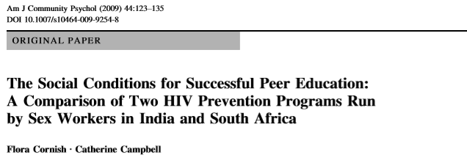

Cornish, F., & Campbell, C. (2009). The social conditions for successful peer education: A comparison of two HIV prevention programs run by sex workers in India and South Africa. American Journal of Community Psychology, 44(1–2), 123–135. https://doi.org/10.1007/s10464-009-9254-8

This abstract describes a comparative puzzle. It involves comparing two peer education interventions—one in India and one in South Africa—to understand the differing outcomes. By examining the context and implementation in each location, the study seeks to explain the factors contributing to success or failure in each case. This comparison highlights the specific social, material, and political conditions that influenced the effectiveness of the interventions, making it a puzzle focused on learning from similarities and differences across these two cases.

Draft an answer to the questions below first on your own before sharing what you found with the rest of your team.

- Identifying research puzzles:
  - Share with colleagues your early thoughts on your research puzzle (if you have one yet). What is the interest of working with research puzzles? What is the interest of formulating them as such in our writings for the readers?
  - Using Jennifer Mason’s (2002) typology of intellectual puzzles below,
- extract the intellectual puzzle from the four abstracts and
- express them in your own words, and
- brainstorm how each abstract might illustrate some of the categories put forward by Mason (NB: the categories may not all be represented in the sample, one abstract can illustrate different types of research puzzles, the objective is to brainstorm not to find the right “one” solution).

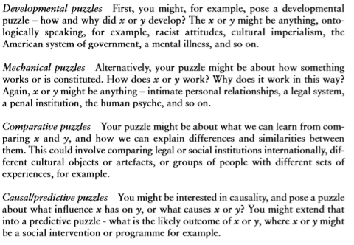

Mason, J. (2002). Qualitative researching (2nd ed.). London: Sage. (Chapter 1, p.13-23).

Discussion #2: Fiorito & Nicholls (2016) and Legate et al. (2022)

Reading guide
In line with the lecture, the reading discussion this week will put in perspective different ways of articulating theory and data in order to produce evidence. In your reading we invite to focus primarily on the introduction/conclusion, theoretical and methodological sections of each paper, first separately and then jointly.

Use the questions below to help you during your reading. The questions below will represent the starting point of our discussion in class.

As you read Fiorito and Nicholls, consider:

Background/literature review
What do the authors claim is already established in the literature in relation to the success of social movements? What is/are the gap/s in the literature that their study is oriented towards?

The authors claim that **existing literature** on social movements establishes that a strong public voice relies on producing unified and resonant frames, narratives, stories, and public performances. Scholars like Benford, Snow, and Polletta have emphasized that **frontstage activities**—the visible, public acts of a movement—are crucial for the success of social movements because they shape how the movement is perceived by the broader public. These unified public performances help construct a positive, coherent identity for the movement, which can be critical in gaining public support and achieving political goals.

However, the gap in the literature that the authors address is the limited focus on backstage processes within social movements. While much of the literature emphasizes frontstage activities, the **backstage work**—the internal preparation, emotional alignment, and conflict management that allow for coherent public displays—is often overlooked. Drawing on Goffman’s dramaturgical perspective, the authors argue that backstage activities are essential to achieving a unified frontstage performance. They suggest that backstage spaces are where **differences are managed**, **emotional solidarity is fostered**, and **strategic identity work** is conducted. By examining these backstage processes, the authors aim to provide a more complete understanding of how movements achieve the disciplined and coherent public performances that contribute to their success.

Research questions
Fiorito and Nicholls do not formally pose research questions that they seek to answer through their research. Do the work for them. Write 2-3 research questions for this study. Try thinking about different sorts of questions that the paper addresses.

- How do DREAMers use backstage processes and spaces to prepare for cohesive and disciplined public performances, and what techniques facilitate this preparation?

- In what ways do ethnographic participation and observation reveal the dynamics of emotional solidarity and collective identity within the DREAMers movement?

- How do backstage interactions among DREAMers, including free spaces for expressing differences, contribute to the construction and maintenance of a unified frontstage identity despite members' diverse backgrounds and perspectives?

Articulating theory and data
- What is the theoretical framework used in this article? What are the key concepts? Synthesise the theoretical framework in a few sentences and identify how/whether the authors define the key concepts they use.

The theoretical framework of this article is based on Erving Goffman’s dramaturgical perspective, particularly the frontstage/backstage approach. In this framework, social interactions are viewed as theatrical performances, where individuals or groups manage the impressions they convey to an audience. For social movements, frontstage refers to public, outward-facing performances intended to project a unified and positive image. The backstage, in contrast, is where preparation occurs, allowing for the expression of internal differences and the development of cohesive, disciplined performances.

Key Concepts:
- Frontstage: The public sphere where activists perform for an external audience. It involves carefully managed presentations meant to convey a specific, unified identity and message.

- Backstage: The private spaces within the movement where members prepare for public performances. Backstage areas allow for rehearsing, resolving conflicts, and aligning individual emotions with the collective identity of the group.

- Impression Management: Techniques used by movement leaders and activists to shape how the movement is perceived. This includes training and emotionally intensive work to ensure members perform in a way that resonates positively with the public.

- Free Spaces: Designated backstage spaces where activists can express differences, explore radical thoughts, and bond emotionally. These spaces facilitate internal dialogue and help manage diverse perspectives without compromising the unified public front.

- What types of data collection strategies do the authors put into place to collect their data? How do the authors try to convince the reader about the rigour of their data collection?

The authors employ ethnographic fieldwork as their primary data collection strategy, with six months of intensive participant observation conducted by the first author. This strategy includes observing both frontstage and backstage activities within the DREAMers movement to gain a comprehensive view of how public performances are prepared and executed. The data collection methods include:

- Participant Observation: The first author immersed herself in the daily activities of the DREAMers, attending 82 events such as weekly meetings, rallies, protests, training sessions, and informal gatherings. This approach allowed her to experience the internal dynamics of the group firsthand, including how members managed differences and prepared for public displays.
- In-Depth Life-History Interviews: Ten life-history interviews with DREAMers were conducted, capturing personal experiences and emotional journeys. Additionally, 34 semi-structured interviews with DREAMers and strategic allies provided insights into individual and group motivations and the role of identity work within the movement.
- Document Analysis: The authors analyzed a variety of digital and hardcopy materials produced by the DREAMers, including Facebook posts, blogs, flyers, posters, and chant lists. These documents helped the researchers understand the movement’s messaging strategies and how specific narratives were communicated.

- As it often happens in published material, the authors do not make explicit whether their research design is inductive, deductive or abductive. Based on your reading of the article, which type of research design did the authors adopt? Do you consider this could be a case where “it is a bit of the three” as introduced in the lecture?

Based on the methods and approach of the study, the authors appear to adopt an **inductive research design**. This is evidenced by their use of **ethnographic fieldwork** to observe the behaviors, interactions, and processes within the DREAMers movement without initially testing a specific hypothesis. Instead, they immerse themselves in the movement, gather detailed observations, and then develop insights and explanations regarding how backstage processes contribute to the frontstage performances and unity of the movement.

However, this study also incorporates elements of **deductive** and **abductive** reasoning, suggesting that it could indeed be “a bit of the three”:

- **Inductive Elements**: The study is driven by observations of the DREAMers' activities, from which the authors derive patterns and insights about how the movement functions. By closely examining the behaviors and backstage work within the movement, they generate broader theories about the role of backstage processes in social movements.

- **Deductive Elements**: The authors draw on **Goffman’s dramaturgical theory** and established concepts in social movement literature to inform their understanding of the DREAMers' actions. While they do not set out to test Goffman’s theory directly, they use its principles to structure their analysis and interpret their observations, particularly in relation to the frontstage/backstage dynamic.

- **Abductive Elements**: Given the unique and evolving context of the DREAMers movement, the authors engage in **abductive reasoning** to make sense of surprising findings or unexpected behaviors. For instance, they examine how DREAMers navigate internal differences and manage identity work, interpreting these as responses to the challenges of presenting a unified public image despite the diversity within the movement. This interpretive approach allows them to explore alternative explanations and understand the movement's practices in real-world complexity.

Therefore, while the research is primarily **inductive**, aimed at generating theory from observation, it also integrates **deductive reasoning** through the application of existing theoretical frameworks and **abductive reasoning** in interpreting nuanced behaviors within the movement. This blend of approaches enables the authors to develop a nuanced understanding of the DREAMers movement and contributes to a more comprehensive analysis of social movement dynamics.

As you read Legate et al. (2022), consider:

The role of theory in shaping research questions and hypotheses
What are the research aims and hypotheses? What role does theory play in these aims and hypotheses?
The research aims of the study are as follows:

1. To determine the effects of autonomy-supportive versus controlling messages** on individuals' motivation, feelings of defiance, and behavioral intentions to engage in social distancing.
2. To assess whether these effects generalize across a diverse, international sample**, analyzing whether message types produce consistent results in different countries.
3. To explore the associations between individuals' existing motivations (autonomous and controlled)** for social distancing and their feelings of defiance and behavioral intentions. The study specifically seeks to understand whether autonomous motivation leads to higher adherence and less defiance compared to controlled motivation.

The study's hypotheses are:
- **Hypothesis 1**: Compared to the controlling message, participants exposed to the autonomy-supportive message or no message will report (1) higher internalized motivation to socially distance, (2) lower feelings of defiance, and (3) higher short-term and long-term intentions to practice social distancing.
- **Hypothesis 2**: Autonomous motivation for social distancing will be associated with (1) lower feelings of defiance and greater short-term and long-term intentions to socially distance, while controlled motivation will show the opposite relationship with these outcomes.

**Role of Theory**: The study is grounded in **Self-Determination Theory (SDT)**, which provides the theoretical basis for these aims and hypotheses. SDT posits that different types of motivation influence behavior and adherence to social norms or recommendations. In this study, SDT is used to predict that autonomy-supportive messages, which align with individuals' internal values and support personal agency, will be more effective than controlling messages, which rely on shame and external pressure. This theory underpins the hypotheses, suggesting that autonomous motivation will result in positive behavior change (increased social distancing) and reduced defiance, while controlled motivation will have the opposite effect. By applying SDT, the authors aim to test the theory’s application in a real-world context, examining how it informs effective public health communication strategies.

Results of the study
What did the authors find? Did their analysis support the theory’s predictions?

The authors found that **autonomy-supportive messages** had modest benefits over **controlling messages** in terms of **reducing feelings of defiance** and **promoting controlled motivation**. Specifically, participants exposed to the autonomy-supportive message reported slightly lower defiance compared to those who received the controlling message. However, the study did not find that these messages significantly impacted participants’ **behavioral intentions** to engage in social distancing.

Key findings include:
- The **controlling message increased controlled motivation** (motivation driven by external pressures, like guilt or shame) compared to no message at all.
- The **autonomy-supportive message lowered feelings of defiance** relative to the controlling message. However, there was no difference between the controlling message and no message in terms of defiance.
- **Messages did not influence autonomous motivation** (highly internalized motivation based on personal values) or **behavioral intentions** to socially distance.
- **Existing motivations** (autonomous vs. controlled) were significantly associated with behavioral intentions to social distance: **autonomous motivation** was linked to **higher intentions and lower defiance**, while **controlled motivation** was associated with **lower intentions and higher defiance**.

### Alignment with Theory
The findings **partially support Self-Determination Theory (SDT)**:
- SDT suggests that autonomy-supportive messages should increase autonomous motivation and adherence while reducing defiance, whereas controlling messages should increase defiance and controlled motivation. The study confirmed that autonomy-supportive messages can reduce defiance compared to controlling messages, aligning with SDT’s predictions regarding the negative impact of controlling messages.
- However, the lack of a significant effect on **autonomous motivation** or **behavioral intentions** to engage in social distancing indicates that the **messaging alone may not strongly influence actual intentions or deeply internalized motivations**. Instead, the study highlighted the stronger role of pre-existing motivations on behavior, suggesting that while messaging can affect certain attitudes, it may not drastically shift behaviors in the short term.

Overall, the results support the **general principles of SDT** by showing that autonomy-supportive approaches can reduce resistance, yet they also reveal **limitations in messaging alone** as a tool for changing long-term behavioral intentions. This suggests that public health strategies may need to combine autonomy-supportive communication with other interventions to effectively foster sustainable behavior change.

Now, consider both together:

Theory played different roles in the two papers. Thinking back to lecture 2, draw out some of the key differences. Reflect, also, on what kind of impact theory made to each study.

